
WEEK 1 DOCUMENTATION & STATUS REPORT

COURSE: COMPUTER NETWORKS (CN-S2026)
INSTRUCTOR: SIR TAHIR MEHMOOD

1. TEAM CHARTER - PROBLEM 7 (PCAP FORENSICS)

Project Goal: To analyze network PCAP traffic, identify compromised nodes, and isolate threat infrastructure.
Team Members:
1. Ariba Waseem (F2024266905)
2. Atiqa Kamran (F2024266914)
3. Ayesha Khan (F2024266918)
4. Ifrah Tariq (F2024266939)

2. WEEK 1 STATUS REPORT
Activities Completed:
- Successfully parsed the raw PCAP file using Wireshark filters.
- Isolated the victim host MAC/IP addresses (192.168.100.103).
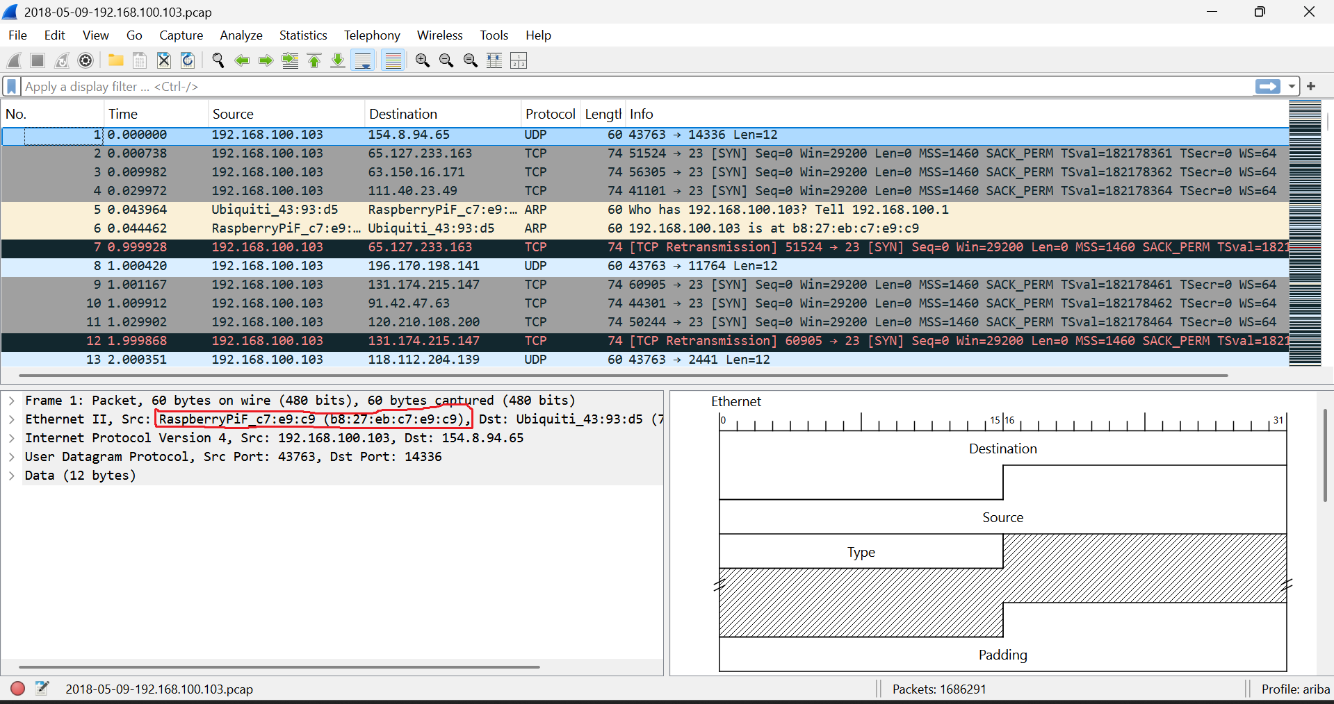
Milestones Achieved:
- Mapped the external Command & Control (C2) server IPs (219.243.27.65 & 71.181.6.40).
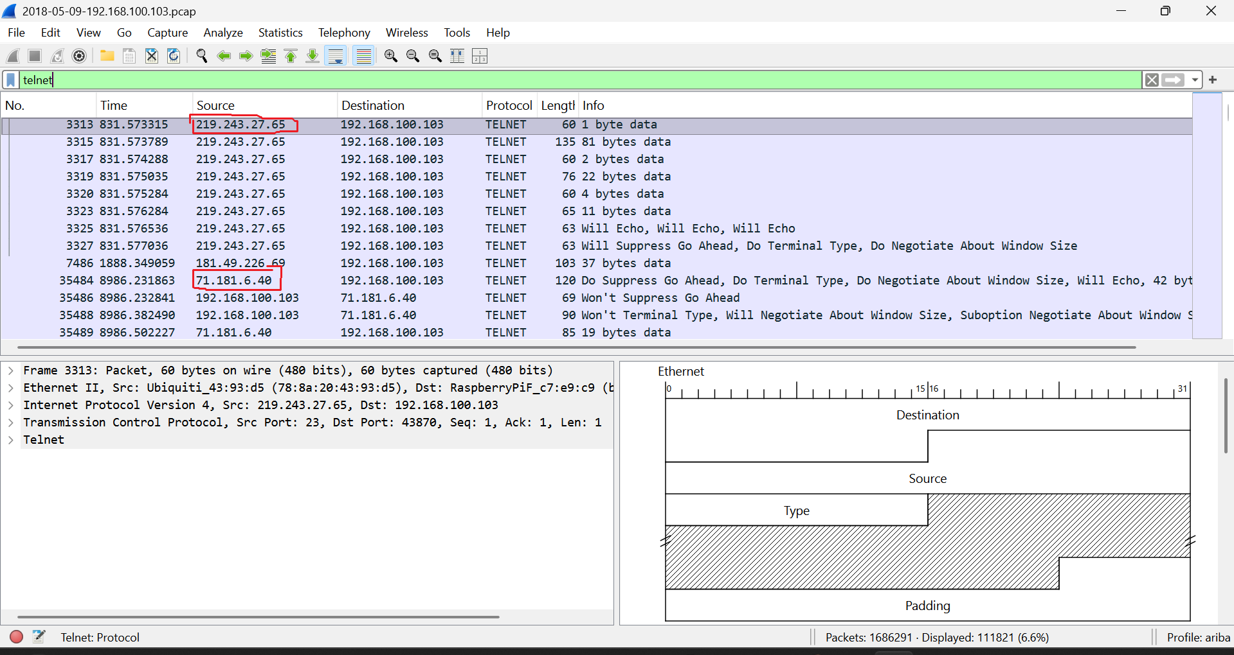
- Identified the plaintext Telnet brute-force attempts from TCP stream logs.
